THREE PHASE FOUR WIRE SHUNT ACTIVE POWER FILTER USING INSTANTANEOUS P-Q THEORY AS CONTROL STRATEGY

Tulsi Sapkota

Sangit Poudel

Sanij Gyawali

Rabin Subedi

Dept. of Electrical Engineering,

Central Campus, Pulchowk, IOE, TU

Lalitpur, Nepal.

[tolsee3@gmail.com](mailto:tolsee3@gmail.com)

***Abstract--*This paper describes the development of Shunt Active Power Filter (SAPF) for the three phase four wire system with balanced and undistorted supply voltage. The filter is designed to improve Power quality problems in electrical system by allowing us to compensate harmonic currents, compensate reactive power and Zero sequence current. Here, instantaneous p-q theory is used to extract reference current. The power stage of SAPF consists of current controlled 3-leged power inverter with split phase capacitors in dc side. The SAPF works as inverter and Injects the harmonic current, reactive current and zero sequence current.**

***Index Terms*—Shunt Active Power Filter (SAPF), p-q theory, Non-linear, Point of common coupling (PCC), Butter-worth filter**

I. INTRODUCTION

Power electronics converters, ever more widely used in industrial, commercial and domestic applications which suffers from the problem of drawing non sinusoidal current and reactive power from the source. Moreover these type of load when connected in unbalance form, they will draw zero sequence current from the source. This behaviour Causes voltage waveform distortion that affects other loads connected at the same Point of Common Coupling and presence of distortion in power lines results larger power losses in lines, interference problem with communication systems, failure in the operation of different electrical and electronic equipments, excessive heating of the transformer coil. Because of these problems the power quality delivered to the end user is of the great concern [1].

Harmonic distortion has traditionally been dealt with the use of passive LC filters. However, the application of passive filters for harmonic reduction may result in parallel

Prof. Dr. Indraman Tamrakar

Associate Prof. Dr. Netra Prasad Gyawali

Department of Electrical Engineering

Central Campus, IOE, T.U.

[im.tamrakar@hotmail.com](mailto:im.tamrakar@hotmail.com)

[netra@ioe.edu.np](mailto:netra@ioe.edu.np)

resonance with the network impendence, overcompensation of reactive power at fundamental frequency, and poor flexibility for dynamic compensation of different frequency harmonic components.

The increased severity of power quality in power networks has obliged to develop dynamic and adjustable solutions to the power quality problems with greater precision and simplicity. Such equipment, generally known as active power filters [2]-[4], and are also called active power line conditioner, and are able to compensate current(shunt APF) and voltage harmonics (series APF), reactive power, zero sequence current. The advantage of active filter is that it automatically adapts to change in the network and load fluctuation. They can compensate several harmonic orders, and are not affected by major changes in network characteristics, eliminating the risk of resonance between the filter and network impedance. Also the take up very little space compared to traditional passive compensator [1].

II. PROPOSED SCHEME

The proposed scheme of SAPF is shown in Fig.1. The SAPF is used such that the source have to provide only the balanced sinusoidal current , the rest of currents which are non-sinusoidal and which contribute for the reactive power are supplied by the power stage of the SAPF which is three leg inverter.

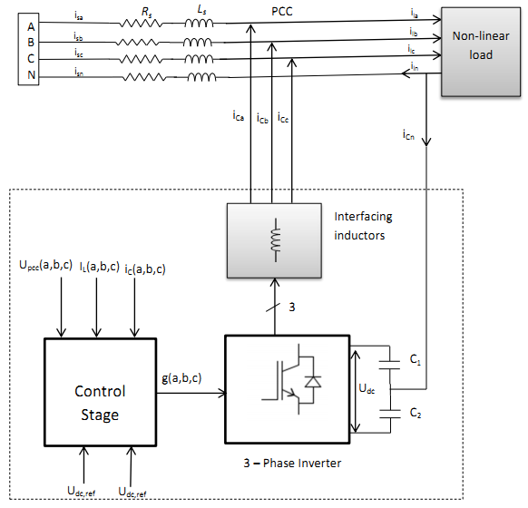

Fig.1 The Proposed scheme of SAPF

In the proposed scheme, the load current and voltage are sensed from each phase(abc) and are sent to the control block, where abc voltages and currents are converted into αβ0 parameters by the use of clarke’s transformation [5]. These αβ0 parameter are used to calculate instantaneous Active power (**p**), instantaneous reactive power(**q)** using p-q theory [2]-[3]. By selecting the power to be compensated, the reference current is extracted and is fed to the hysteresis band controller which is closed loop current controller. This current controller generates the gate signal to the inverter circuit by comparing reference current with the actual current fed by filter itself so that the actual tracks the reference current within the specified band. Two dc link capacitors act as the energy storing device and, gets charged and discharged during one cycle of load current.

III. CONTROL STRATEGY

The control block realizes the instantaneous p-q theory for calculating reference currents by taking instantaneous value of phase voltages and load currents as the input. Additionally, the signal ${\overline{p}}_{loss}$ from dc regulator block [6] is also fed into this block which accounts for the power loss in capacitor during voltage fluctuation across the capacitor. Fig:2 shows the complete modelling of the control block.

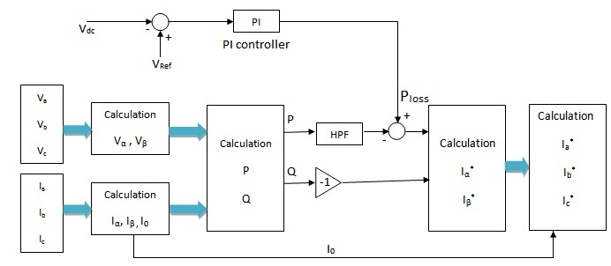

Fig. 2 The illustration of reference current calculation

The voltages and current in αβ0 axis are calculated by using equations (1) and (2).

$\left[\begin{aligned}v_{0} \\ v_{α} \\ v_{β}\end{aligned}\right]$ = $\sqrt{\frac{2}{3}}\left[\begin{matrix}\frac{1}{\sqrt{2}} & \frac{1}{\sqrt{2}} & \frac{1}{\sqrt{2}} \\ 1 & \frac{-1}{2} & \frac{-1}{2} \\ 0 & \frac{\sqrt{3}}{2} & \frac{-\sqrt{3}}{2}\end{matrix}\right]\left[\begin{aligned}v_{a} \\ v_{b} \\ v_{c}\end{aligned}\right]$ (1)

$\left[\begin{matrix}i_{0} \\ i_{α} \\ i_{β}\end{matrix}\right]$ = $\sqrt{\frac{2}{3}}\left[\begin{matrix}\frac{1}{\sqrt{2}} & \frac{1}{\sqrt{2}} & \frac{1}{\sqrt{2}} \\ 1 & \frac{-1}{2} & \frac{-1}{2} \\ 0 & \frac{\sqrt{3}}{2} & \frac{-\sqrt{3}}{2}\end{matrix}\right]\left[\begin{aligned}i_{a} \\ i_{b} \\ i_{c}\end{aligned}\right]$ (2)

Load side instantaneous active and reactive power components are calculated by using voltage and current values on αβ0 frame as given in equation (3)

$\left[\begin{aligned}p_{0} \\ p \\ q\end{aligned}\right]$ = $\sqrt{\frac{2}{3}}\left[\begin{matrix}v_{0} & 0 & 0 \\ 0 & v_{α} & v_{β} \\ 0 & -v_{β} & v_{α}\end{matrix}\right]\left[\begin{matrix}i_{0} \\ i_{α} \\ i_{β}\end{matrix}\right] (3)$

Since, it is only concerning balanced and undistorted source voltage, the above equation reduces to

$\left[\begin{aligned}p \\ q\end{aligned}\right]$ = $\sqrt{\frac{2}{3}}\left[\begin{matrix}v_{α} & v_{β} \\ {-v}_{β} & v_{α}\end{matrix}\right]\left[\begin{aligned}i_{α} \\ i_{β}\end{aligned}\right] (4)$

The instantaneous active and reactive power consists of DC and AC component i.e. $P=\overline{P}+\tilde{P}$ and $q=\overline{q}+\tilde{q}$**.** DC component of ***p*** and ***q*** consists of the positive sequence components of fundamental load current, whereas AC component of ***p*** and ***q*** consists of harmonic and negative sequence of load currents. The objective of p-q theory is to get the source to give only the constant active power demand by the load so the power $\tilde{P}$ and ***q*** is compensated. High pass filter is used to separate the oscillating part of the active power and the reference current in abc phases are calculated using following two equations:

$\left[\begin{aligned}{i_{α}}^{ref} \\ {i_{β}}^{ref}\end{aligned}\right]$ = $\frac{1}{{v_{α}}^{2}+{v_{β}}^{2}}\left[\begin{matrix}v_{α} & -v_{β} \\ v_{β} & v_{α}\end{matrix}\right]\left[\begin{aligned}-\tilde{p}+{\overline{p}}_{loss} \\ -q\end{aligned}\right] (5)$

$i_{0}^{ref}=i_{0}$ from equation(2) since we have $v_{0}=0$

$\left[\begin{aligned}i_{a} \\ i_{b} \\ i_{c}\end{aligned}\right]$ = $\sqrt{\frac{2}{3}}\left[\begin{matrix}1 & 0 \\ \frac{-1}{2} & \frac{\sqrt{3}}{2} \\ \frac{-1}{2} & \frac{-\sqrt{3}}{2}\end{matrix}\right]\left[\begin{aligned}i_{α} \\ i_{β}\end{aligned}\right] (6)$

These reference current are fed in each phases by the power inverter in order to get complete compensation. After this source will be providing balanced steady power whereas the oscillating power is provided by inverter itself.

IV. HIGH PASS FILTER

Butterworth filter of second order having frequency response as shown in Fig.3 is designed using Matlab with cut-off frequency 111.7323 rad/s with sampling frequency of 3*k*Hz.The transfer function associated, in z domain is

$$\frac{Y(z)}{X(z)}=\frac{z^{2}-1.999z+0.9993}{z^{2}-1.947z+0.9487} (7)$$

Difference equation is calculated and programmed in Matlab:

(8)

|  |
| --- |
| HPF.bmp  Fig.3 Frequency response of high pass filter |

V. MATLAB BASED SIMULATION

The Power Supply, Unbalanced and Non- Linear Load and Shunt Active Filter are modeled in Matlab using Simscape Library. Fig. 4 shows the Simulation blocks to study the performance of the APF. The voltage source block consists of a three-phase voltage supply with its internal impedance. Load consists of three diode rectifiers connected to each phase and a neutral with unequal arm. The rectifier fed load has been modeled as diode rectifier feeding resistor and inductor, which will cause harmonic and unbalanced current flow also some reactive power will be consumed by this load.

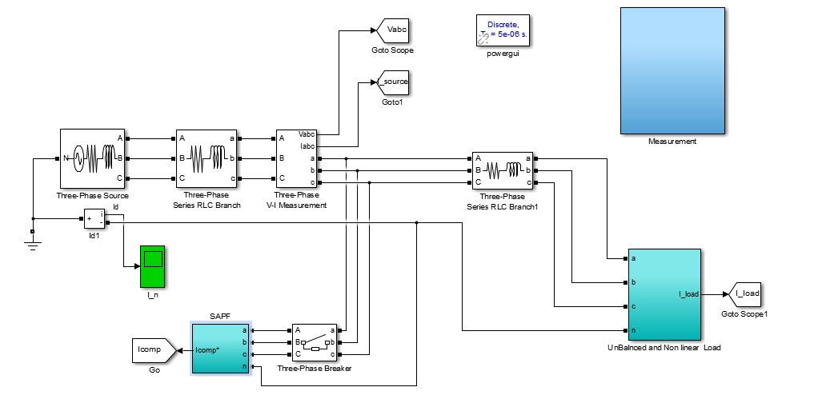

Fig. 4 Main block of proposed scheme under MATLAB

The Shunt Active Power Filter block consists of three main parts: a) The Inverter, b) The controller, c) Hysteresis controller. The Controller is fed with measurements of load currents, PCC voltages and capacitor voltages. This block will calculate the reference current that will be fed to hysteresis controller. Hysteresis controller in addition with Inverter current will generate the switching logic of the Inverter.

Inverter consists of six IGBT’s forming three legs. The DC side is a split phase capacitor (C=400μF each). The voltage of each capacitor is sensed and fed to the PI controller in order to compensate for the losses. The forward voltage of both IGBT devices and diodes is 1V. The switching times of IGBT are 1μs.

TABLE I

THE PARAMETERS OF SIMULATED SYSTEM

|  |  |
| --- | --- |
| Mains voltage per phase | 400v |
| Line frequency | 50Hz |
| Coupling Inductance | 2mH |

TABLE II

THE PARAMETERS OF SIMULATED LOAD

|  |  |
| --- | --- |
| **Phase** | **Load** |
| A | (10Ω,0.1H) |
| B | (15Ω,0.1H) |
| C | (5Ω, 0.1H) |

TABLE III

THE PARAMETERS OF PI CONTROLLER

|  |  |
| --- | --- |
| **Vref** | 1200 |
| Kp | 0.7 |
| Ki | 1 |

*A. Simulation Results without SAPF:*

Entire system is simulated to observe the nature of the current, active and reactive power drawn by the non- linear unbalanced load without connecting SAPF. The simulation results are shown in Fig.5 to Fig.8. Fig.5 shows the waveform of instantaneous active power. Fig.6 shows the waveforms of line currents of three phase source, which are nearly square waves. Fig.7 shows the wave form of neural current, which indicates that line currents are un-balanced. Fig.8 shows the waveform of instantaneous reactive power.

TABLE IV

THD ANALYSIS WITHOUT SAPF

|  |  |
| --- | --- |
| Phase | THD% |
| A | 43.91% |
| B | 42.46% |
| C | 44.25% |

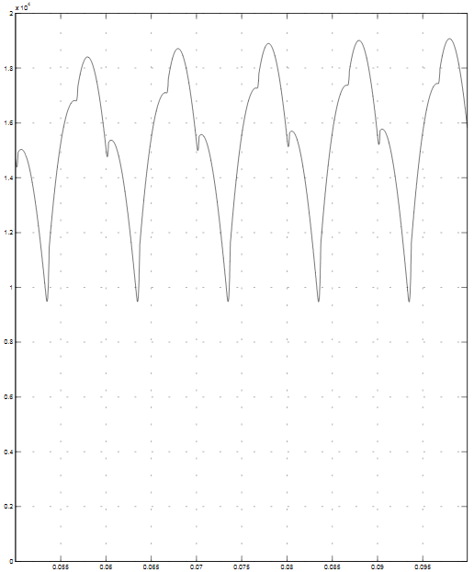

Fig. 5 Waveform of instantaneous Active power (P)

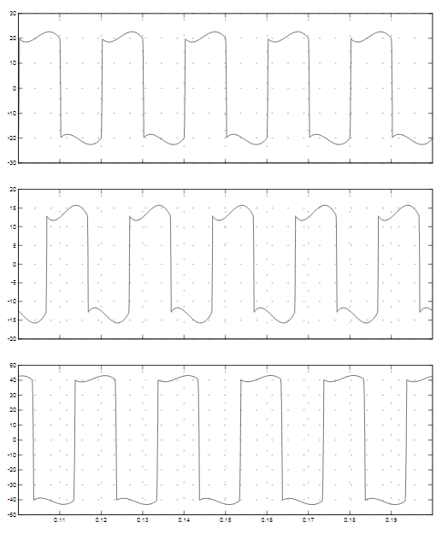

Fig. 6 Waveforms of Line currents

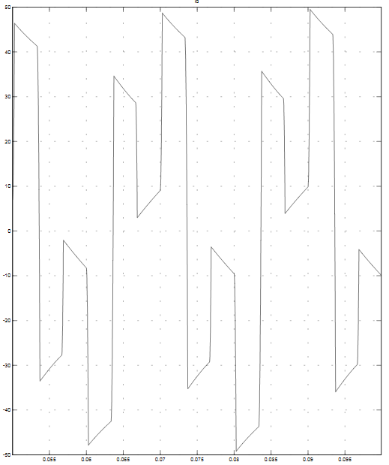

Fig.7 Waveform of neutral current

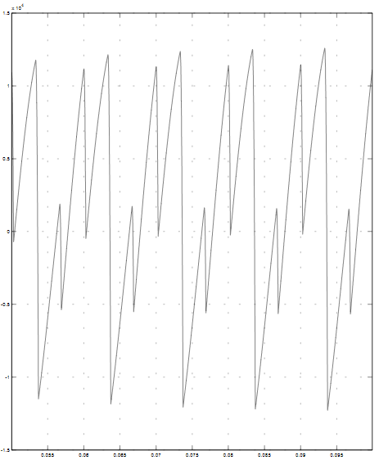

Fig. 8 Waveform of instantaneous reactive power (q)

*B. Simulation Results with SAPF:*

Entire system with SAPF is simulated to observe the nature of the current, active and reactive power drawn by the non- linear unbalanced load. The simulation results are shown in Fig.9 to Fig.12. Fig.9 shows the waveforms source line currents of three phase, which are nearly sinusoidal. Fig.10 shows the waveform of instantaneous active power. Fig.11 shows the waveform of instantaneous reactive power. Fig.12 shows the wave form of neural current, which is nearly zero, which indicates that line currents are balanced.

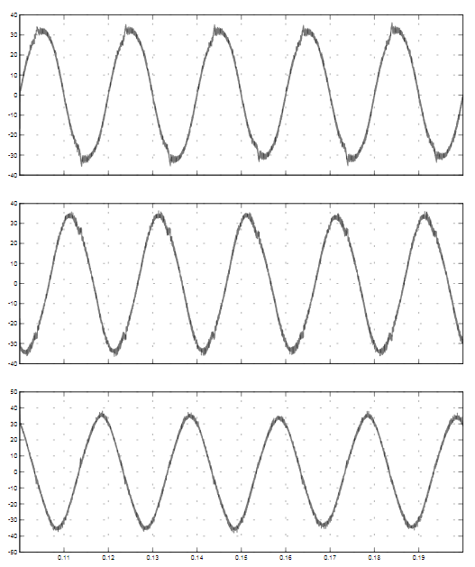

Fig. 9 Waveforms of Source currents

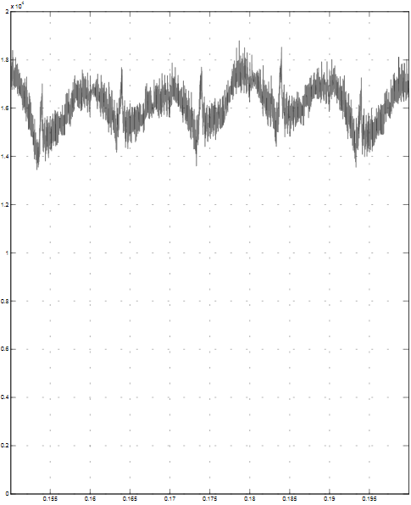

Fig.10 Waveform of instantaneous active power

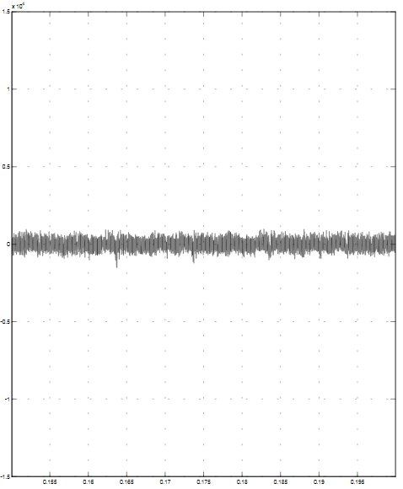

Fig.11 Waveform of instantaneous reactive power

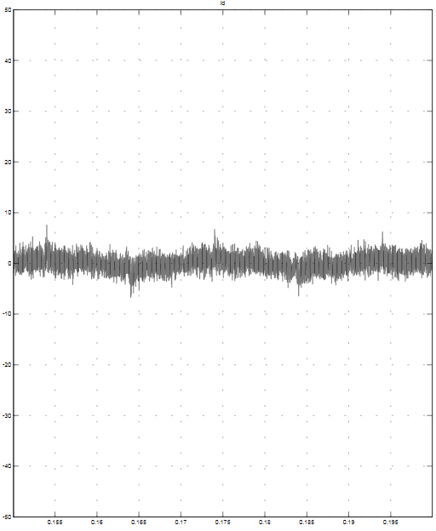

Fig.12 Waveform of neutral current

After SAPF is connected into the system. The compensated system is able to satisfy the IEEE-519 standard harmonic current limit [7].

TABLE V

THD ANALYSIS WITH SAPF

|  |  |
| --- | --- |
| Phase | THD% |
| A | 4.88% |
| B | 4.99% |
| C | 4.22% |

VI. CONCLUSIONS

From the simulation results, it is observed that by the use of SAPF, source current is obtained with the allowable harmonic content (<5%), source current is balanced and the power factor is greatly improved. From the results obtained, we may conclude that the Active filters are an up-to-date solution to power quality problems. P-q control strategy is best suitable for balanced and undistorted voltage source than others like UPF, PHC and d-q theory because of its simplicity and satisfactory results.

# References

[1] Rashid,M. H. (Ed). Power Electronics Handbook: Devices,Circuits, and Applications,3rd Ed, Butterworth-Heinemann Publisher,2011, pp.1193-1228.

[2] H. Akagi, Y. Kanazawa, and A. Nabae, “Generalized Theory of Instantaneous Reactive Power and Its Applications,” *Transactions of the IEE-Japan,* Part B, vol. 103, no.7, 1983,pp,483-490(in Japanese).

[3]Bhimsingh, Kamal Al-Haddad, and Ambrish Chandra, “A Review of Active Filters for Power Quality Improvement,” *IEEE Transactions on Industrial Electronics, vol. 46, no. 5, October 1999*

[4] María Isabel Milanés Montero, Enrique Romero Cadaval, and FermínBarrero González, “Comparison of Control Strategies for Shunt ActivePower Filters in Three-Phase Four Wire Systems,” *IEEE Transactions on Power Electronics, vol. 22, no. 1,January 2007*

[5]E. Clarke, *Circuit Analysis of A-C Power Systems, Vol. I-Symmetrical and Related Components*, Wiley, 1943.

[6]R. L. A. Ribeiro, T. O. A. Rocha, R. M. Sousa, E. C. dos Santos Jr., and A. M. N. Lima, “A Robust DC-Link Voltage Control Strategy to Enhance the Performance of Shunt Active Power Filters without Harmonic Detection Schemes,” *IEEE Transactions on Industrial Electronics, 2013*

[7]*IEEE Recommended Practices and Requirement for Harmonic Control in Electrical Power System,*IEEE Std. 519-1992, 1992.